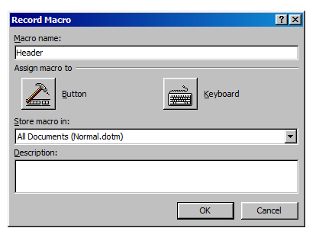

I decided to create a macro for the header

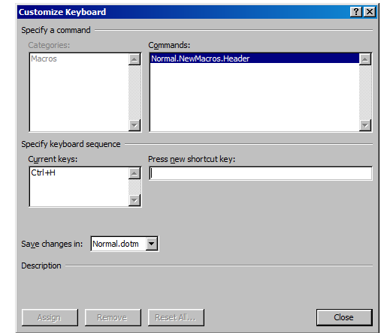
Decide your shortcut key which will later appear if you press it.

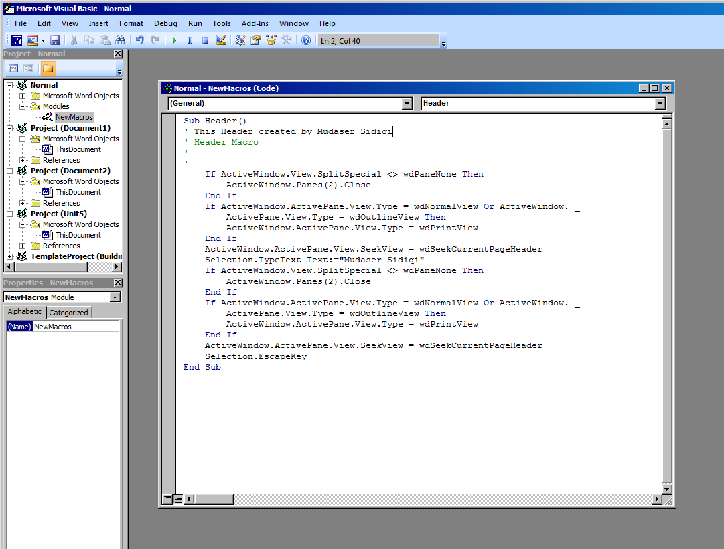
Here is my macro header and the text I wrote for the header was Mudaser Sidiqi Unit 9, so every time I press the shortcut that will appear.

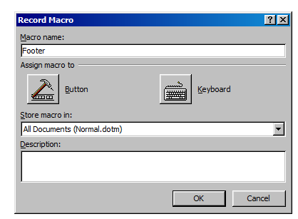
The last one I created was for the Footer.

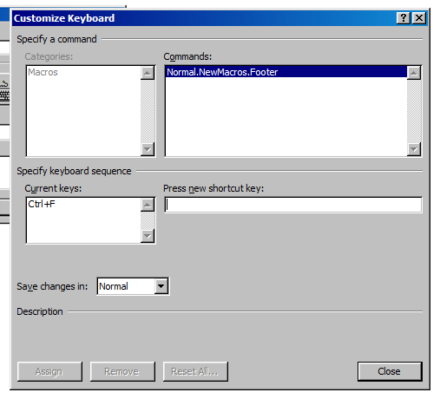

My shortcut key

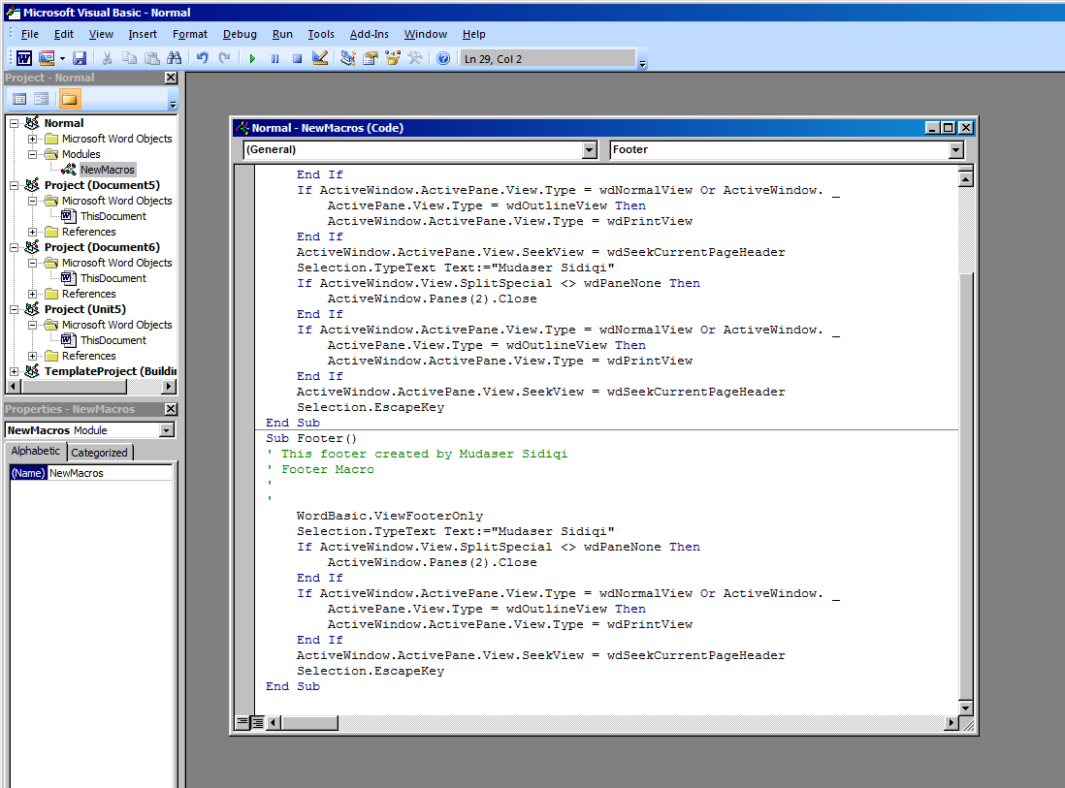
Here is the code for the Footer.

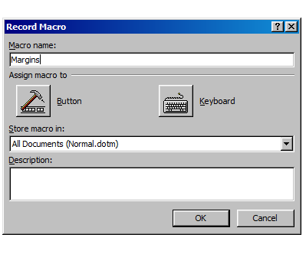
I created a new one but this time for the Margins.

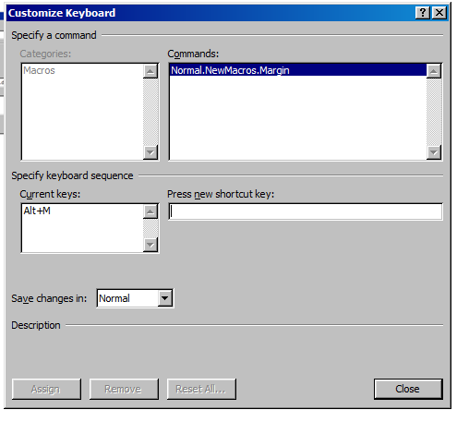

My shortcut key

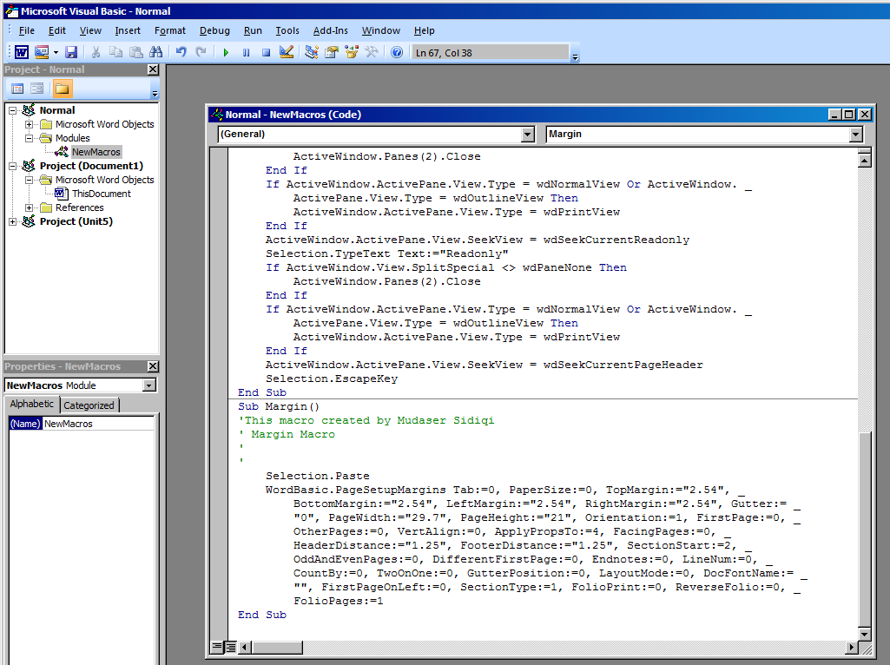
This is my code for margins

